Word | Definition | Picture
Mechanical Engineer | a branch of engineering that deals with tools, machinery, and the application of mechanics in industry | 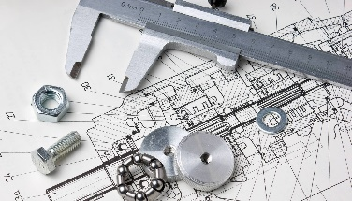
Civil Engineer | an engineer whose training or occupation is in the design and construction especially of public works (such as roads or harbors)
Industrial Engineer | engineering that deals with the design, improvement, and installation of integrated systems (as of people, materials, and energy) in industry | 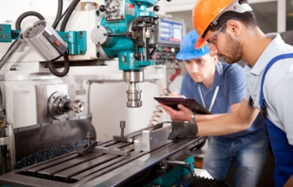
Round About | indirect; a circular area at a place where several roads meet. | 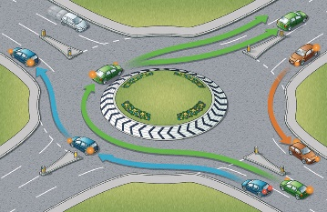
Pallet | a small, hard, or temporary bed | 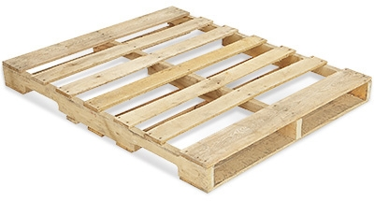
Mezzanine | a low-ceilinged story between two main stories of a building; especially : an intermediate story that projects in the form of a balcony | 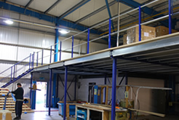
Divert | to turn from one course or use to another

